How to Read Journal Articles

Know the structure of a research article. A research article will typically contain the following sections: Abstract, Introduction, Methods, Results, Conclusion, and References.

Know what each section contains.
Abstract Summary of the key points.
Introduction Contains a survey of the relevant background and the hypothesis.
Methods/Observations/Procedure
Describes the approach taken in the study.
Results Data is summarized in this section.
Conclusion Results are summarized in narrative form.
References Alphabetical listing of the sources.

Now you are ready to read.
Not first page to last page, unless you are really familiar with the topic.
- Start with the Abstract.
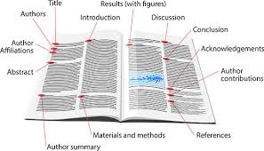
- Read the Introduction to get a sense of the issue.
- Skim the Conclusion to see how the study turned out.
- Now, go back to the middle part for the details. Read the Methods section, highlight the important points, and critique the strategies used.
- Then, read the Results section. Don’t get bogged down in the details of either the Methods section or the Results section, but try to get a good idea of what has been observed.
- Read the Conclusion section more closely.
- Finally, skim the whole article, first page to last page. Review for the greatest comprehension.

Finally, take notes on the article.
Use a Research Article Summary sheet to write notes about the research article. The summary sheet will provide a quick reference to the study and will help you avoid plagiarism.

Image source: https://tinyurl.com/yaov476e

