Overcoming Electronic Distractions
If you get pulled away from tasks by every ding, whistle, and ring on your digital devices, well, you’re like most of us. But keep in mind that other people aren’t interrupting you, you are interrupting yourself!
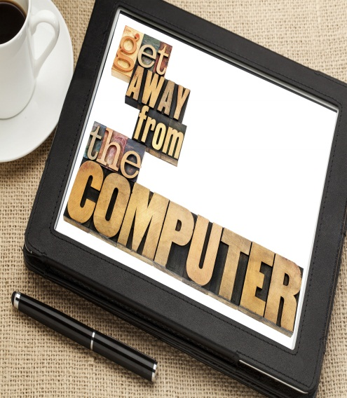
- Turn off or silence your phone while studying.
- Leave unessential devices behind when working. For example, leave your laptop in your room when going to the library to read a book.
- If you must bring your electronic device, turn off automatic alerts for emails, text messages, and social media so that you are not constantly interrupted.
- Unplug from the internet.
- Disconnect the internet cable from your laptop or set your device to “airplane mode” to disable your Wi-Fi.
- RescueTime tracks your every online move and provides easy-to-read, painfully revealing charts. Seeing your wasted time in pretty graphs is a bracing slap in the face. (That’s how much time I spent on Facebook yesterday?!?)
- Do certain websites suck up all of your time? LeechBlock works with the Firefox internet browser so you can block certain sites – or all of them—perpetually or during specific periods.
- Freedom Internet Blocking Productivity software disables all roads to the internet for an allotted amount of time. Cheating isn’t easy – to sneak back online early, you have to reboot your computer.

