Overcoming Procrastination

"I don't wait for moods. You accomplish nothing if you do that. Your mind must know it has got to get down to work."
~ Pearl S. Buck

I have plenty of time to get it done.
Get started on the task right away so that you are ahead of schedule. Unexpected things always come up later.

Parkinson’s Law states that work expands to fill the time allotted. If you have 2 weeks for a paper, it will take two weeks to get it done, usually at the last minute. Set a deadline that is difficult to meet and reward yourself for getting it done early.

I don’t “feel” like doing it.
Feelings are irrational. It is important to prioritize your goals.

Use the five-minute plan.
Work on the task for just 5 minutes and then decide if you want to continue.
Chances are you will keep going.

Make your plans public by writing them down or telling others about them. It’s harder to avoid working on a task when your friends are asking how you are doing on it.

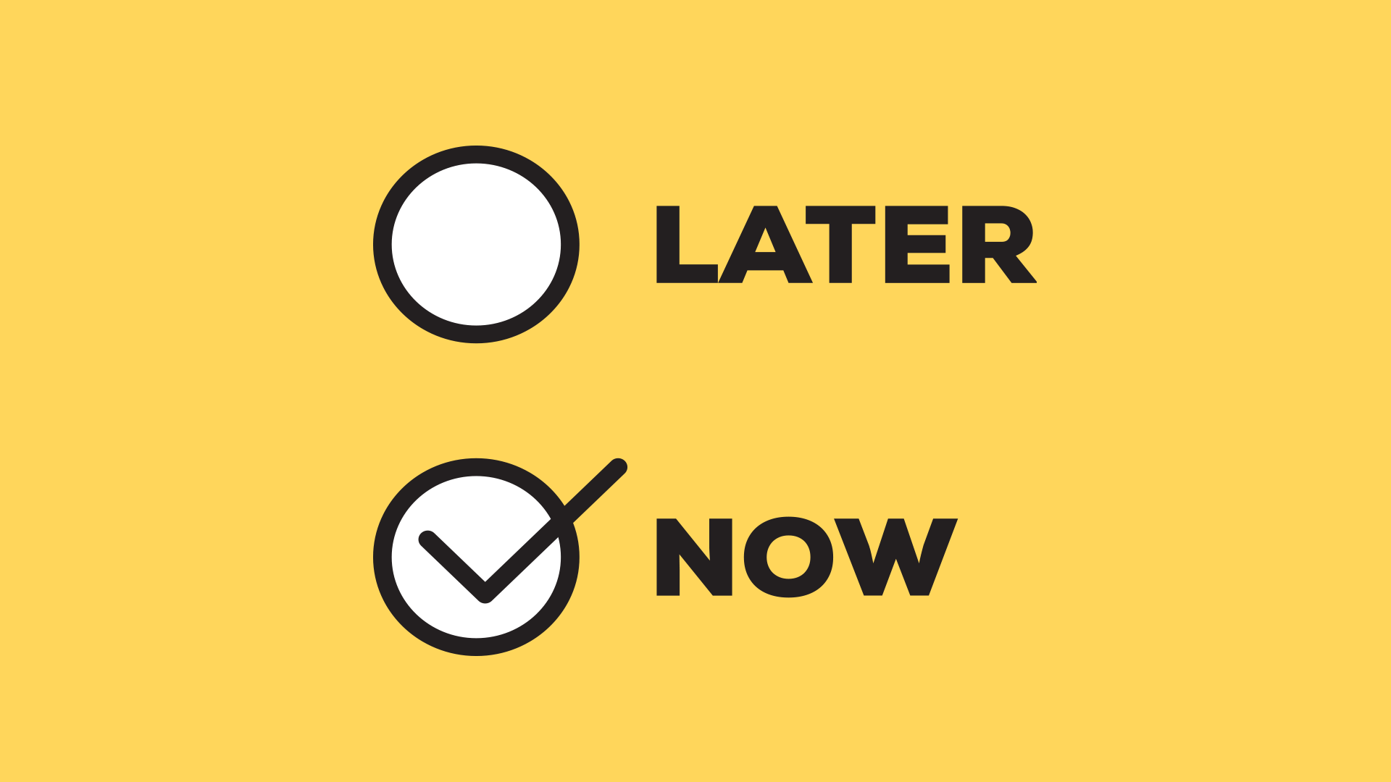
I work better under pressure.
This is a myth.
Avoid undue stress by starting on a task right away. You might even have time to get help with it
if it is done far enough in advance.

I have better (more enjoyable things) to do.
Complete your least favorite tasks first and get them out of the way.

Reward yourself with fun activities after getting a task done.

Find a study space free from distractions.

Image source: https://www.fulcrumlabs.ai/blog/procrastination/

