Project Management

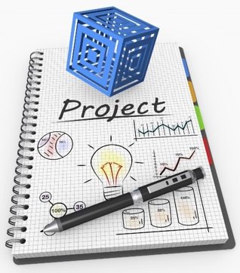
- CREATE A CHECK LIST:
Identify the tasks then break the tasks into subtasks.

- ESTIMATE:
How much time will each task take?
- PARALLEL VS. SEQUENTIAL TASKS:
Determine if task relationships are Sequential (tasks that need to be completed before you can start next) or Parallel (tasks that can be done concurrently).

- CONSIDER CONSEQUENCES:
Sometimes things take longer than expected. So, allow for some wiggle room
- GET ORGANIZED:
Keep a project/design notebook, or programing notes. Develop a system for filing paper documents. Keep your data and results together. Create a digital archive of documents you can use Evernote, Endnote, or Zotero for this.
- HAVE CHECK POINTS:

Meet with your group or supervisor regularly. Give presentations on your progress or create personal deadlines

- DEALING WITH GROUPS:
Assign roles, tasks, and get communication information from group members. The problem might not be group member laziness but lack of communication. Email your professor early in the project after you have already attempted to talk to group member via email and in

